Mrs. Elizabeth, Mrs. Leslie, Mrs. Kelly, and Mrs. Daphne’s Weekly Buzz
October 5 - 9, 2020
Dates to Remember
Oct. 6 – Deadline for Flu Shot Papers
Oct. 9 – Picture Day
Oct 26-30 Red Ribbon Week (More info to come)
Snacks
We would love some healthy snacks for our morning snack break. Pretzels, animal crackers, gummies, cheezits, fruit etc. . .
We have 19 students in our class!!
What we’ve been reading…
During each story throughout the week we have been learning new vocabulary words. We’ve searched for the new words in each book, have discussed their meanings, and used them in sentences.

A Tree for All Seasons
New Vocabulary: season, sap, boil, veins
Forest Night, Forest Bright
New Vocabulary: stumble, burrow, jabber, hollow
Biscuit Loves the Library
New Vocabulary: puppets, librarian, cozy, spot
Try using some of these new vocabulary words with your little ones during everyday conversation.

LETTERS this WEEK:
We have worked hard on the Letters
Bb & Mm
Ask your child something that starts with these letter sounds.
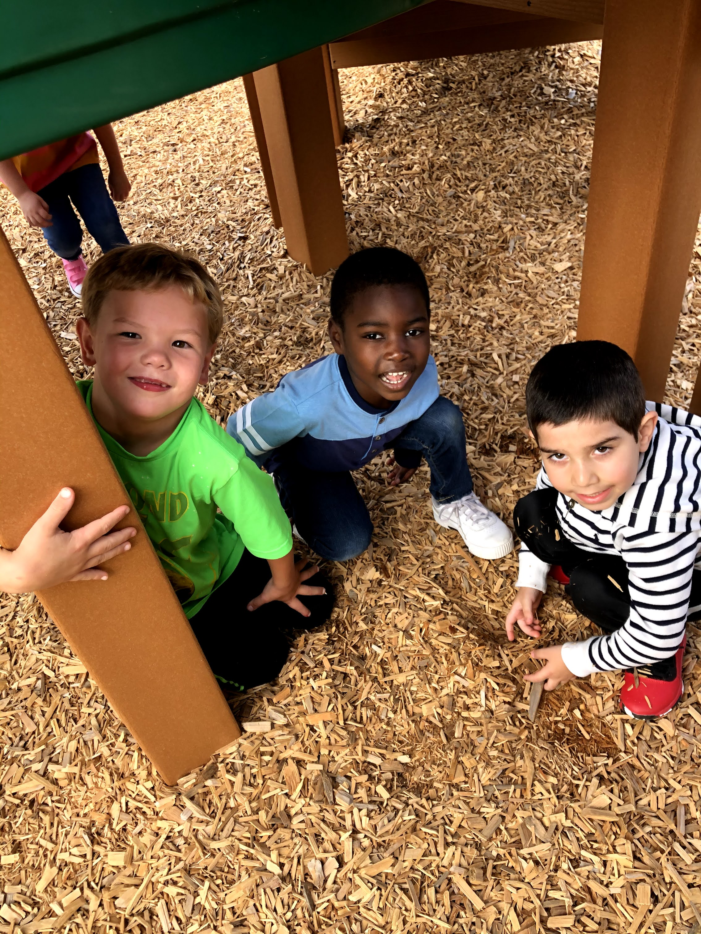
Math Skills
We have continued to work on counting by ones and recognizing and describing 2D and 3D shapes. This week we worked on Subitizing. Subitizing is when you can look at a number of objects and say the number quickly and without counting.

